Karnatak Law Society’s
GOGTE INSTITUTE OF TECHNOLOGY
Udyambag Belagavi -590008 Karnataka, India.



A Course Project Report on
“Mongo Db INSTALLATION ON WINDOWS 10”
Submitted for the requirements of 6th semester B.E. in CSE for “BIG DATA MANAGEMENT (18CS642)”
Submitted by

NAME USN
- Umesh Bhati 2GI19CS168
- Prathamesh Kesti 2GI19CS096
- Vinayak Desai 2GI19CS180

Under the guidance of
Prof.Arati .S. Shahapurkar

Academic Year 2021-2022 (Even semester)

Karnatak Law Society’s
GOGTE INSTITUTE OF TECHNOLOGY
Udyambag Belagavi -590008 Karnataka, India.
Department of Computer Science and Engineering

Certificate
This is to certify that the Course Project work titled “Mongo Db INSTALLATION ON WINDOWS 10 ” carried out by Umesh Bhati, Prathamesh Kesti , Vinayak Desai bearing 2GI19CS168 , 2GI19CS096 , 2GI19CS180 is submitted in partial fulfilment of the requirements for 6th semester B.E. in COMPUTER SCIENCE AND ENGINEERING, Visvesvaraya Technological University, Belagavi. It is certified that all corrections/ suggestions indicated have been incorporated in the report. The course project report has been approved as it satisfies the academic requirements prescribed for the said degree.
Date: 10-05-2022 Signature of Guide

Place: Belagavi Mrs.Arati.S.Shahapurkar

Assistant Professor KLS Gogte Institute of Technology, Belagavi

Name of the Examiners Signature of the Examiners

1. 1.

2. 2.

Table of contents
S.NO Concepts
- Problem Statement
- Theory
- Real life applications
- Procedure for installation
- Conclusion
- References

PROBLEM STATEMENT:

To install Mongo Db on Windows 10.

Theory:

Mongo Db is an open source installation Database, Mongo Db is an Non-Relational DataBase which stores data in the form of documents. Here tables are known as collections, Data is stored in the form of Key Value Pairs.



REAL LIFE APPLICATIONS:
- eBay. eBay is a multinational company that provides a platform for the customer to customer sales

- MetLife. MetLife is a leading company in employee benefit programs, annuities, and insurance

- Shutterfly
- Aadhar.
- EA.

PROCEDURE FOR INSTALLATION:

Download and install msi file

First we need to download msi (MicroSoft Installation)file for the required bit system.
Go to the following path
C:\Program Files\MongoDB\Server\5.0\bin

Copy the Above Path and open Command Prompt paste the path in cmd.

And Mongodb is installed in Your System.

The below link is to download the msi file

https://www.mongodb.com/try/download/community

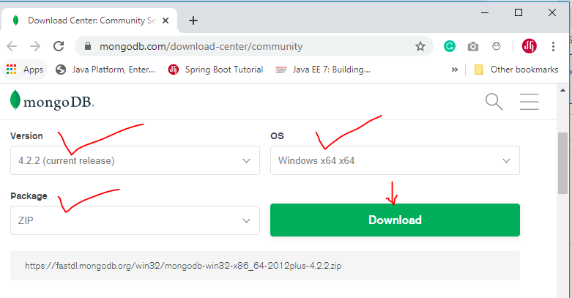
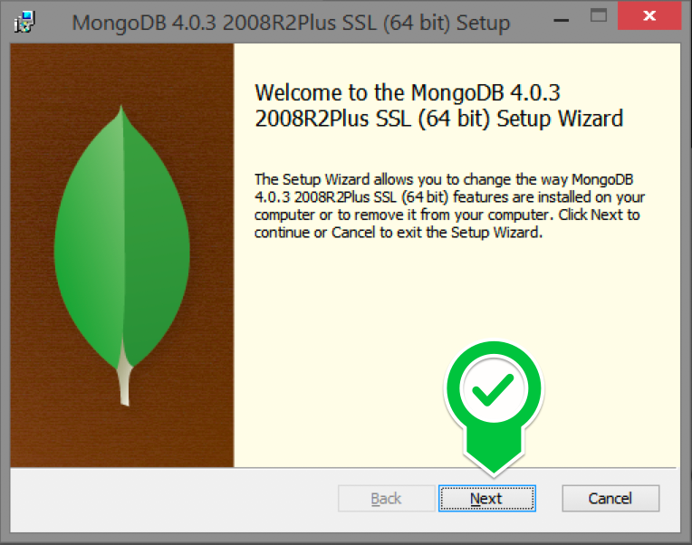

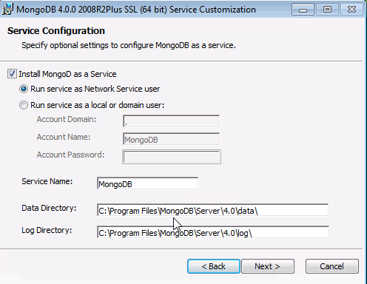



5)Conclusion:

We have successfully completed installation of mongo DB on Windows 10 system and Mac Book.
And we also understood how to work with mongo DB and its real time applications.

6)Refernences:

https://www.mongodb.com/try/download/community

